Group 15

Interactive Data Visualization

Lab 3

|  |  |
| --- | --- |
| Dhruvi Mehta | 202318003 |
| Prachi Mehta | 202318008 |
| Riya Dave | 202318011 |
| Simran Dalvi | 202318042 |

Part 1

1. **Scatterplot**

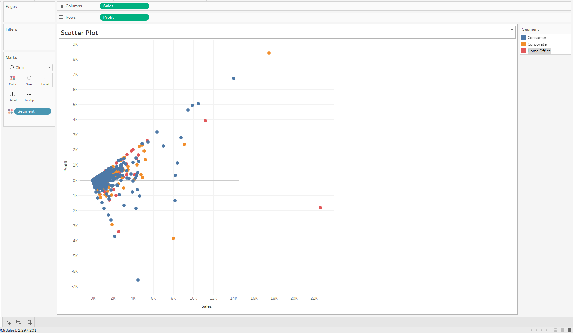

The scatter plot reveals that the Consumer segment, though dominant in volume, has mixed profitability, with many instances of negative profits, suggesting a need for strategy refinement. The Corporate segment shows potential with some high sales, but the mixed profit outcomes indicate inefficiencies that need addressing. The Home Office segment, though smaller, has a few high-profit outliers, suggesting it could be leveraged for greater profitability. Overall, the Consumer segment requires a focus on improving efficiency, the Corporate segment on managing costs, and the Home Office segment on scaling successful strategies.

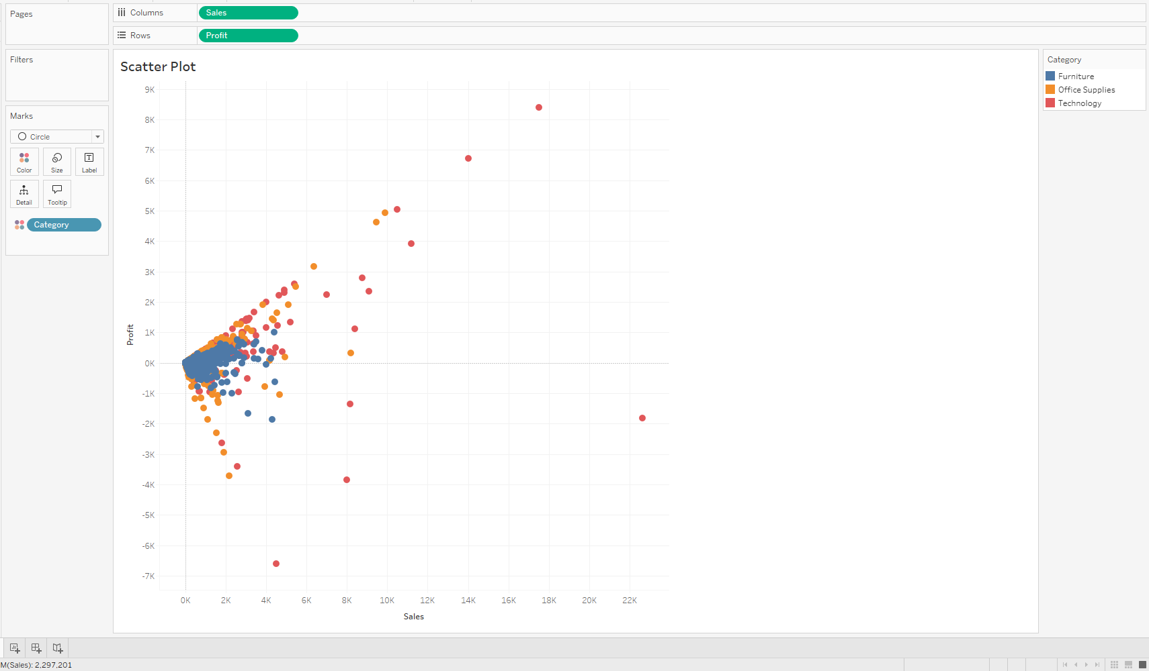

The scatter plot reveals key insights across the Furniture, Office Supplies, and Technology categories. Technology stands out, with high sales frequently leading to significant profits, though a few instances show negative returns. Office Supplies generally provide consistent, moderate profits with minimal losses, indicating steady performance. In contrast, the Furniture category displays more variability, with several sales leading to losses, despite high sales figures. To enhance profitability, focus should be on optimizing the Furniture category by addressing cost and pricing issues, while leveraging the strong performance in Technology and scaling successful strategies in Office Supplies

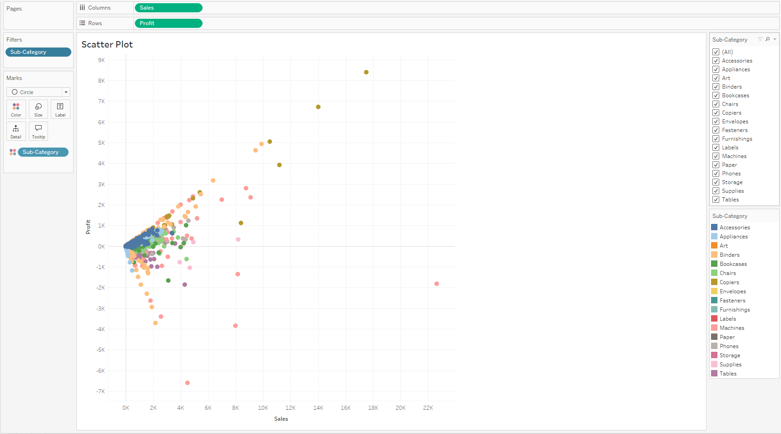

The scatter plot reveals a generally positive relationship between Sales and Profit across most Sub-Categories, with profits increasing as sales rise. However, some Sub-Categories show high profits even at lower sales levels, while others exhibit negative profits despite significant sales, indicating potential inefficiencies. The colour differentiation highlights performance variations, with some categories clustering around moderate sales and profits, and others appearing as outliers with high sales but varied profitability. These insights suggest that while many Sub-Categories are performing well, specific areas may require closer analysis to improve profitability.

1. **Trend Lines**

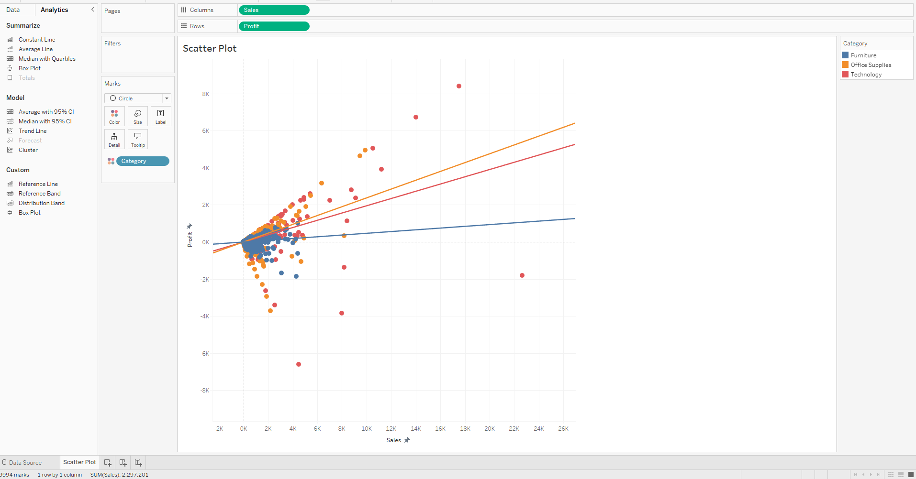

The scatter plot shows the relationship between sales and profit across three categories: Technology, Office Supplies, and Furniture. Technology demonstrates the strongest positive correlation between sales and profit, indicating higher profitability with increased sales. Office Supplies also shows a positive trend, though with less consistency. Furniture, however, reveals a weak or flat correlation, with some points showing high sales but negative profits, suggesting inefficiencies. The data is mostly clustered at lower sales and profit levels, with greater variability as sales increase, particularly in Technology and Office Supplies.

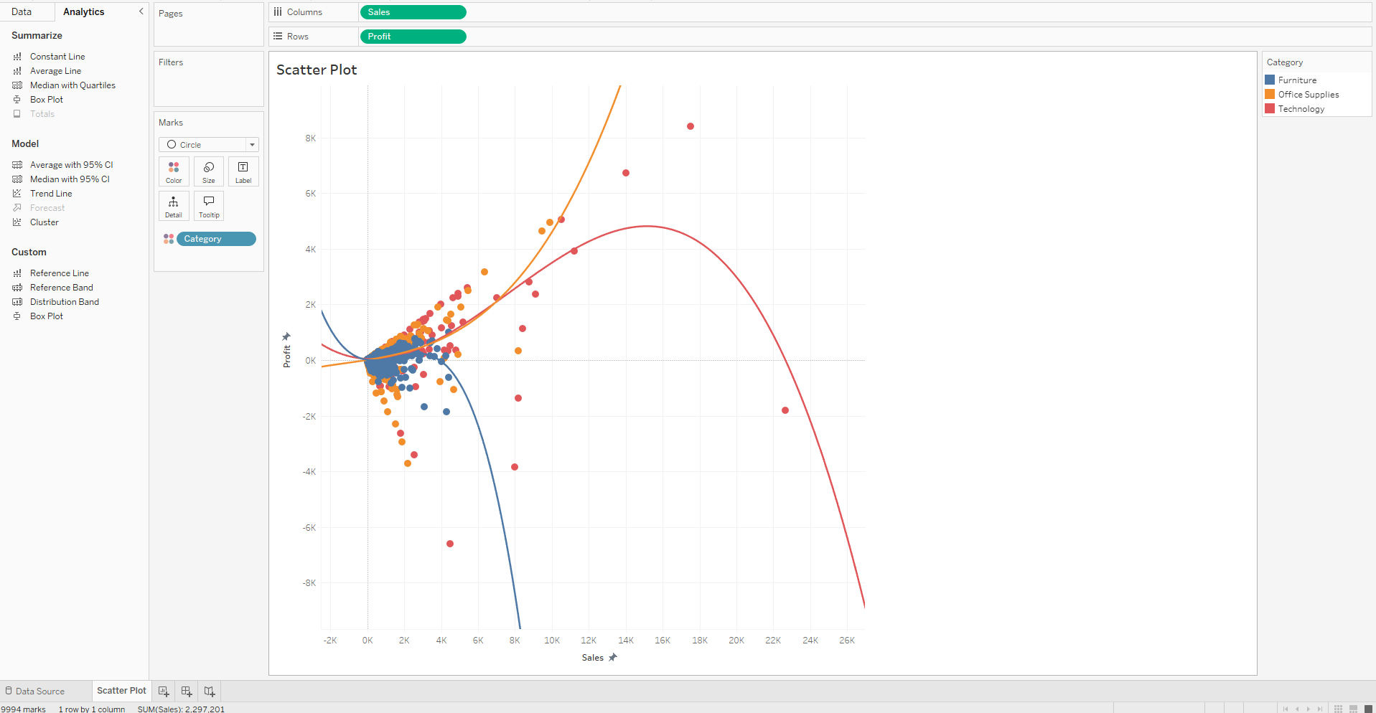

The scatter plot shows polynomial trend lines for Sales vs. Profit across three categories: Furniture, Office Supplies, and Technology. Office Supplies (Orange) shows a strong upward curve, indicating profitability rises as sales increase. Technology (Red) follows a parabola, with profits declining at high sales, suggesting diminishing returns or increased costs. Furniture (Blue) displays a sharp decline in profitability as sales grow, indicating a potential issue with costs or inefficiencies. Overall, Furniture and Technology have profitability challenges, while Office Supplies performs well at higher sales levels.

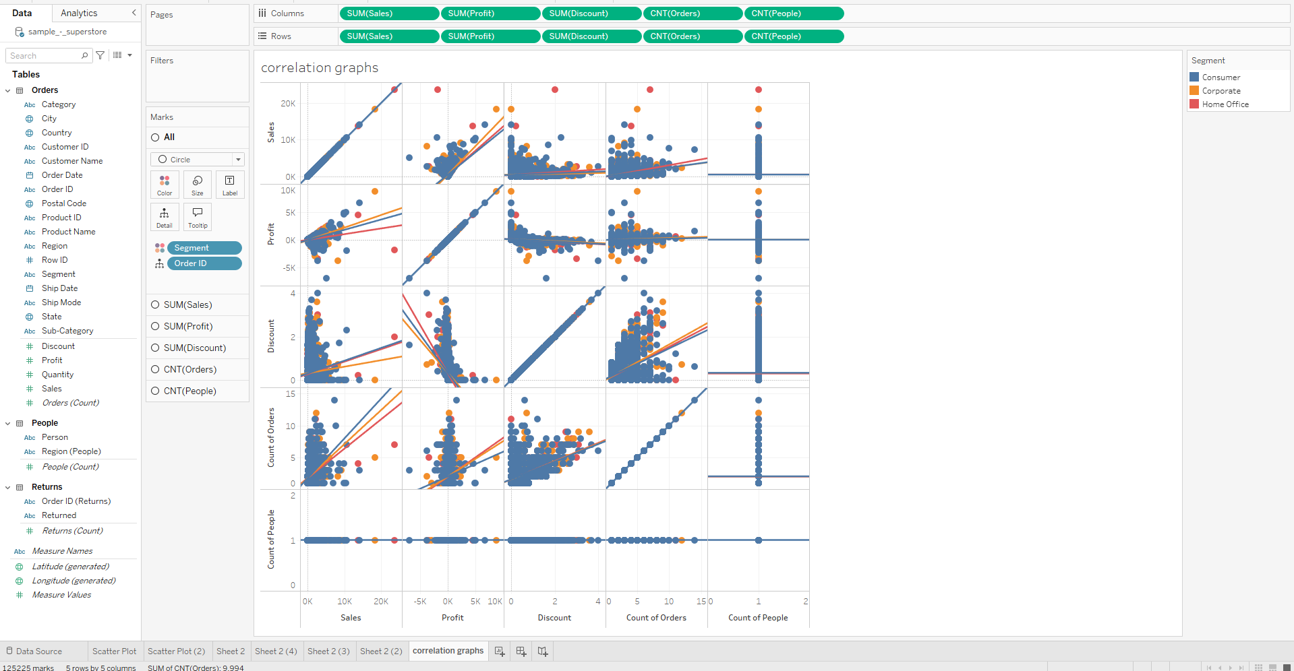

Part 2

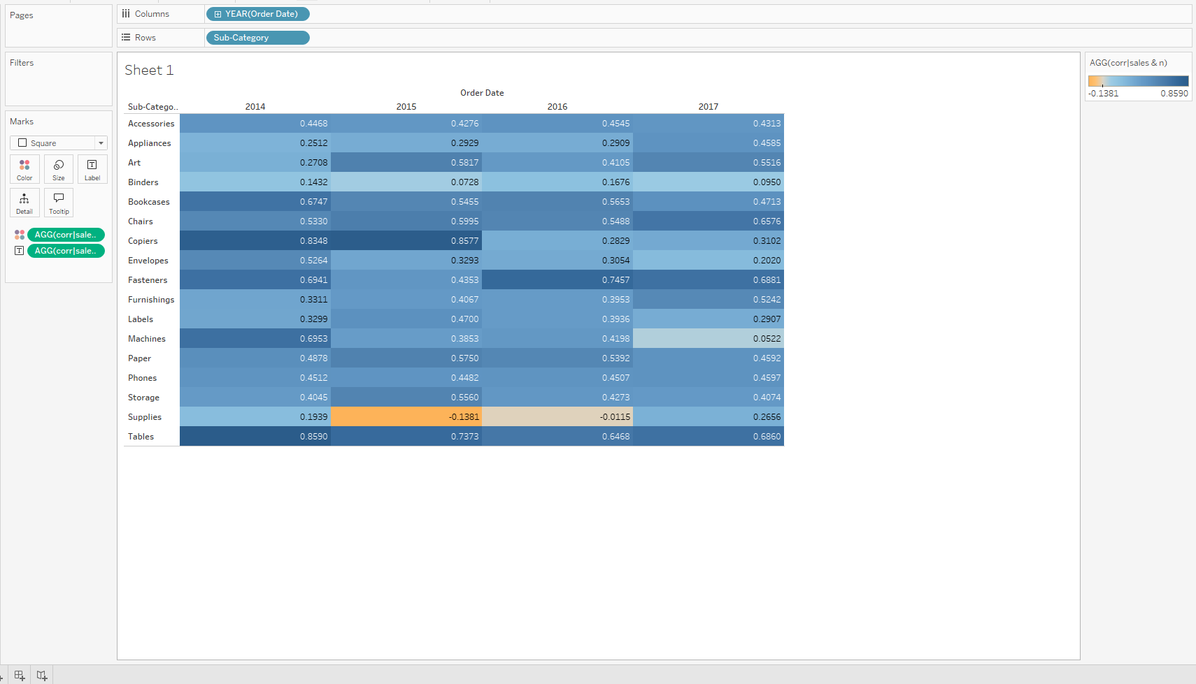

The heatmap visualizes the correlation between sales and another metric across different sub-categories from 2014 to 2017. Key insights include:

Strong Positive Correlations: Sub-categories like "Tables" and "Fasteners" consistently show high positive correlations across years, indicating that as sales increase, the other metric (likely profit or quantity) also increases significantly.

Negative Correlations: The "Supplies" sub-category in 2015 shows a negative correlation, suggesting that an increase in sales might be associated with a decrease in the other metric during that year.

Variability: Correlations fluctuate over the years for many sub-categories, reflecting changing relationships between sales and the other metric

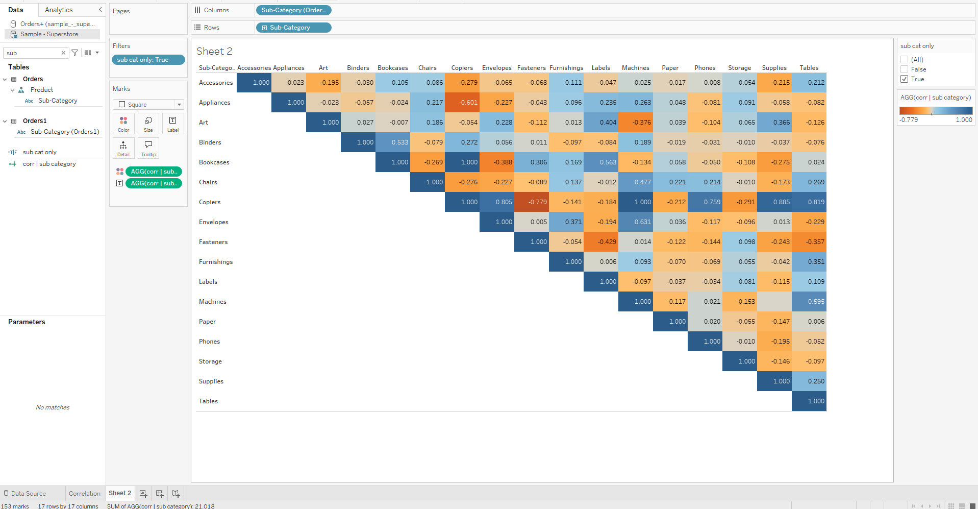

The heatmap provides a detailed view of the correlation between different product sub-categories in the dataset. Key insights include:

High Positive Correlations: For instance, "Tables" and "Chairs" have a strong positive correlation of 0.819, indicating these sub-categories tend to increase in sales together.

Strong Negative Correlations: "Copiers" and "Furnishings" exhibit a significant negative correlation of -0.779, suggesting that an increase in sales for "Copiers" might lead to a decrease in sales for "Furnishings."

Moderate Correlations: "Machines" and "Labels" have a moderate positive correlation of 0.631, reflecting a potential complementary relationship in purchasing behavior.

This heatmap aids in understanding which sub-categories have linked or opposing sales trends, providing actionable insights for inventory management and cross-selling strategies.